**Narrative:**

The hospital tracks the treatments administered to patients and the treating doctor. Treatments are tracked by name, description, and charge. The hospital also tracks the date and time of each treatment administered and the results. Some doctors treat patients while others do not.

A given patient may receive no treatments or may receive many, and some patients may receive their treatments from more than one doctor. Some treatments have yet to be used while others have been used often.

In addition to treatments, patients incur other charges for items used during their stay. The hospital tracks these charges as “items” and stores information on what items have been charged to which patients, based on date and quantity. Information that is to be stored for each item includes the item name and charge. All patients incur at least one charge for consumable items used during their stay. Some items are used often while items may be new or unusual in nature and might rarely or never be charged to any patients.

Lastly, the hospital tracks nurse patient care. Each nurse-patient care interaction is an event. There are several types of events: wellness check, medication, food service, assistance, treatment admin, and “other.” Given the number of shifts and ward rotations, a patient will typically be seen by more than one nurse during their stay, and a nurse most likely will interact with the same patient over several events during a single shift.

**REPORTS**

The administrator runs the following reports:

1. Daily report of beds occupied and beds available.

2. Weekly report of patients admitted and discharged, sorted by date of admission,

admitting physician, discharging physician.

3. Patient discharge report listing name, treatments received, treating physician, date of

service.

4. Monthly report of physician admits.

5. Shift Rotation report of nurse patient care.

6. Summary of charges for a patient stay.

7. Ward scheduling report with name of charge nurse.

8. Patient ward assignment report.

9. Patient treatment report with and without treating physician.

10. Physician treatment report of dates and types of treatments.

11. Report of Physicians and their specialties.

12. Report of Nurses with their certifications and ward assignments, including those who

supervise.

**Requirements (Actors/Roles):**

**Patients**: Patients are admitted to the hospital for treatments

**Doctors**: Doctors treat admitted patients

**Nurses**: Nurses are assisting doctors for the treatment that they are doing to the patients. They also assist the Patients.

**Wards**: Wards contains Beds in the hospital where a bed is assigned to a patient

**Beds**: Different types of beds are available based on the preferences of the patient

**Items**: Patients may or may not use items during the stay in the Hospital

**Treatments**: patients may or may not undergo Treatment and these are assigned/suggested by the Doctor.

**Entities**:

* DOCTORS
* PATIENTS
* NURSES
* WARDS
* BEDS
* TREATMENTS
* ITEMS

**Entities with Nested Attributes:**

1. **Nurse**:
   1. NurseId PK
   2. Address
   3. Phone & alternate phone
   4. Email
   5. Specialties
   6. Supervisor
2. **Ward**:
   1. WardId Pk
   2. Descriptive Name
   3. Physical Location
   4. Phone Number
3. **Beds**:
4. BedId Pk
5. Size(s,l,xl)(default:L)
6. Type(E,M)(default:M)
7. Availability(O or A)
8. **Patient**:
9. Patient Id
10. Name
11. Gender
12. DOB
13. Age
14. Address
15. Phone
16. Alternate Phone
17. Email
18. Admitted Date
19. Discharged Date
20. Admit Doctor
21. Discharged Doctor

5**)Doctor**:

1. DoctorId Pk
2. Doctor Name
3. Address
4. Phone
5. Alternative phone
6. Email
7. Medical Specialty

6)**Treatment:**

1. Treatment ID
2. Name
3. Description
4. Charge

7)**Items:**

1. Items Id
2. Name
3. Charge
4. Date & time

**Business Rules:**

**Nurse**: Some nurses supervise one or more other nurses. No nurse is supervised by more than one nurse, and some nurses are unsupervised.

**Doctor**: Some doctors admit patients while others do not. The admitting doctor and discharging doctor is tracked.

**Patients**: The date that the patient is admitted to the hospital, the admitting doctor and the date, doctor discharging the patient. Bed is assigned to the patient after getting admitted to the hospital. Patients may or may not receive treatment. Patients incur charges on items used during the stay in the hospital.

**Wards**: A nurse is assigned to at least one ward and rotates assignments among other wards. Each ward has a charge nurse and only one charge nurse. Wards contain hospital beds for patients.

**Beds**: When a patient is admitted to the hospital they are assigned to a specific bed. Not all beds are available for use all the time, and a bed may not be assigned to more than one patient. By default, many of the beds are large and manual.

**Items**: All patients incur charges based on the items they avail during their stay in the hospital. Some items are used often while items may be new or unusual in nature and might rarely or never be charged to any patients.

**ERD**:

**EERD**:

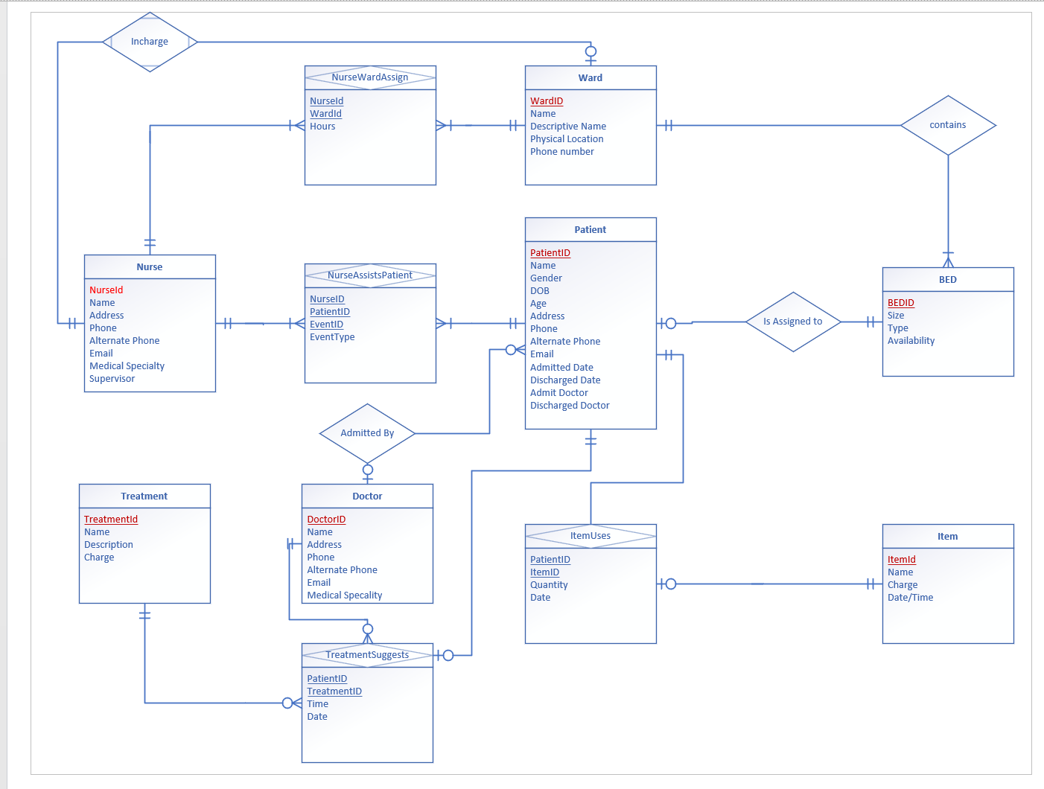

**RS Diagram:**

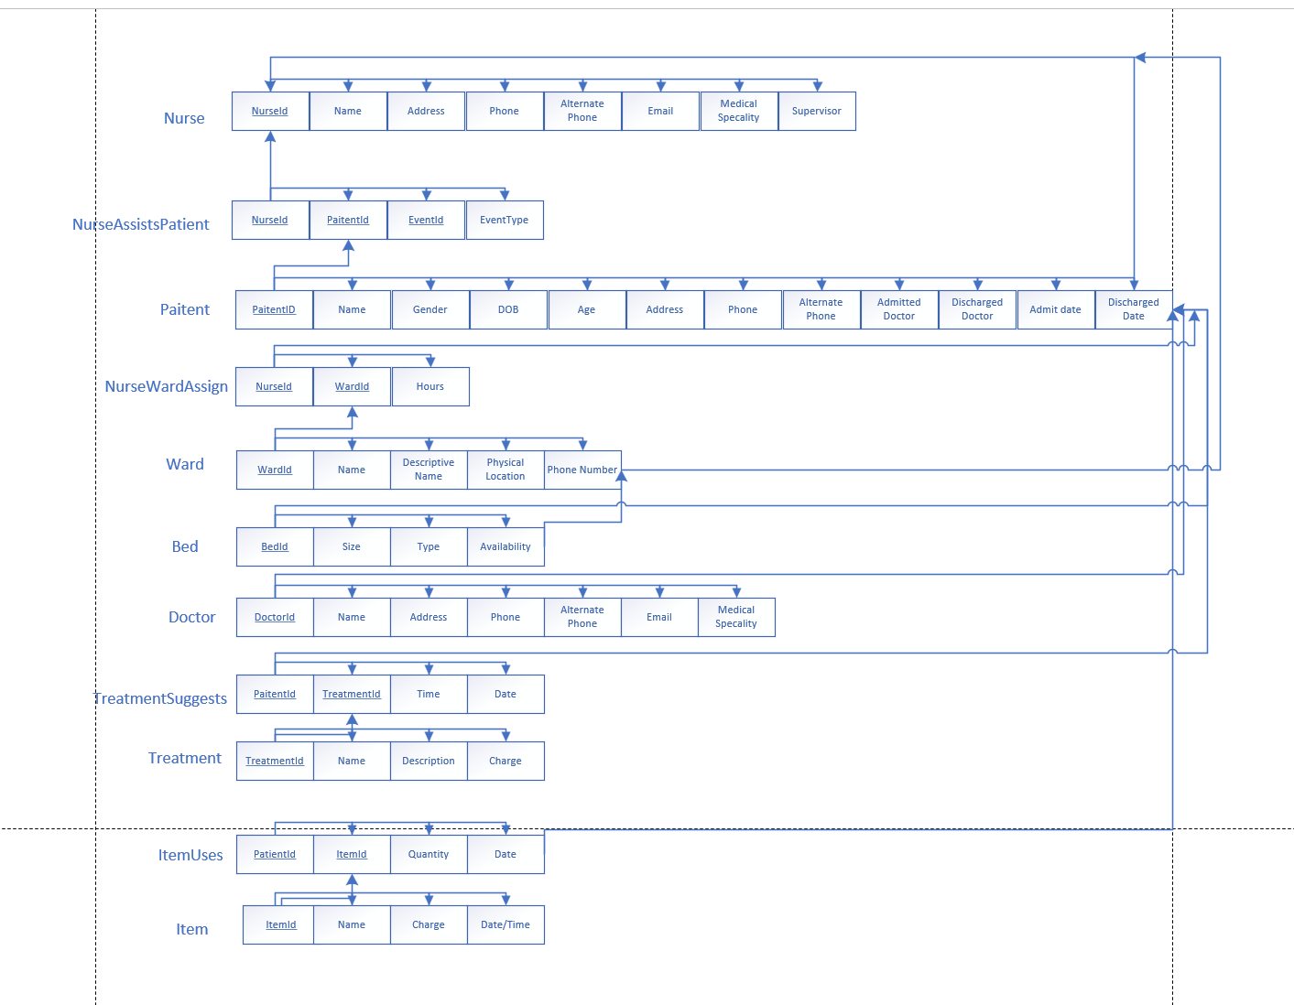

**Data Dictionary:**

Table: Nurse

|  |  |  |  |  |  |  |  |  |  |
| --- | --- | --- | --- | --- | --- | --- | --- | --- | --- |
| **Column Name** | **Description** | **Data Type** | **Size** | **Identity** | **Unique** | **Default** | **Check** | **Allow Nulls** | **Index** |
| NurseId | **PK**:Unique Nurse ID Number | int |  | Y | Y |  |  |  | Y |
| Address | Address of the Nurse | Varchar | 50 |  |  |  |  |  | Y |
| Phone & alternate phone | Nurse Contact Number | int | 10 |  |  |  |  |  |  |
| Email | Nurse Email Id | varchar | 30 |  |  |  |  |  |  |
| Specialties | Specialties of Nurse | varchar | 50 |  |  |  |  |  |  |
| Supervisor | Nurse Supervisor | Varchar | 30 |  |  |  |  |  |  |

Table: Ward

|  |  |  |  |  |  |  |  |  |  |
| --- | --- | --- | --- | --- | --- | --- | --- | --- | --- |
| **Column Name** | **Description** | **Data Type** | **Size** | **Identity** | **Unique** | **Default** | **Check** | **Allow Nulls** | **Index** |
| WardId | **PK**:Unique Ward ID | int |  |  | Y |  |  |  |  |
| Descriptive Name | Ward Description | varchar | 50 |  |  |  |  |  |  |
| Physical Location | Location of the ward | varchar | 100 |  |  |  |  |  |  |
| Phone Number | Ward supervisor number | int | 10 |  |  |  |  |  |  |

Table: Beds

|  |  |  |  |  |  |  |  |  |  |
| --- | --- | --- | --- | --- | --- | --- | --- | --- | --- |
| **Column Name** | **Description** | **Data Type** | **Size** | **Identity** | **Unique** | **Default** | **Check** | **Allow Nulls** | **Index** |
| BedId | **PK**:Unique Bed ID | int |  |  | Y |  |  |  |  |
| Size | Size of the bed (S, L, XL) | Varchar | 2 |  |  | L |  |  |  |
| Type | Type of the bed( E, M) | char | 1 |  |  | M |  |  |  |
| Availability | Availability of the bed( O, A) | char | 1 |  |  |  |  |  |  |

Table: Patient

|  |  |  |  |  |  |  |  |  |  |
| --- | --- | --- | --- | --- | --- | --- | --- | --- | --- |
| **Column Name** | **Description** | **Data Type** | **Size** | **Identity** | **Unique** | **Default** | **Check** | **Allow Nulls** | **Index** |
| Patient Id | **PK**:Unique Patient ID | int |  |  | Y |  |  |  |  |
| Name | Name of the Patient | varchar | 50 |  |  |  |  |  |  |
| Gender | Gender of the patient | varchar | 10 |  |  |  |  |  |  |
| DOB | Date of birth of the patient | DATE | - |  |  |  |  |  |  |
| Age | Age of the patient | int | 3 |  |  |  |  |  |  |
| Address | Address of the patient | varchar | 100 |  |  |  |  |  |  |
| Phone | Contact num of the patient | Int | 10 |  |  |  |  |  |  |
| Alternate Phone | Alternate phone of the patient | Int | 10 |  |  |  |  |  |  |
| Email | Email of the patient | varchar | 100 |  |  |  |  |  |  |
| Admitted Date | Admitted date of the patient | DATE | - |  |  |  |  |  |  |
| Discharged Date | Discharged date of the patient | DATE | - |  |  |  |  |  |  |
| Admit Doctor | Admitted Doctor of the patient | varchar | 50 |  |  |  |  |  |  |
| Discharged Doctor | Discharged doctor of the patient | varchar | 50 |  |  |  |  |  |  |
| DoctorId | Assigned Doctor Fk to Doctor table | Int |  |  |  |  |  |  |  |
| NurseId | Assigned Nurse Fk to nurse table | Int |  |  |  |  |  |  |  |

Table: Doctor

|  |  |  |  |  |  |  |  |  |  |
| --- | --- | --- | --- | --- | --- | --- | --- | --- | --- |
| **Column Name** | **Description** | **Data Type** | **Size** | **Identity** | **Unique** | **Default** | **Check** | **Allow Nulls** | **Index** |
| DoctorId | **PK**:Unique Doctor ID | int |  |  | Y |  |  |  |  |
| Doctor Name | Name of the doctor | varchar | 50 |  |  |  |  |  |  |
| Address | Address of the doctor | varchar | 100 |  |  |  |  |  |  |
| Phone | Phone of the doctor | Int | 10 |  |  |  |  |  |  |
| Alternative phone | Alternate of the doctor | int | 10 |  |  |  |  |  |  |
| Email | Email of the doctor | varchar | 50 |  |  |  |  |  |  |
| Medical Specialty | Specialties of the doctor | varchar | 100 |  |  |  |  |  |  |

Table: Treatment

|  |  |  |  |  |  |  |  |  |  |
| --- | --- | --- | --- | --- | --- | --- | --- | --- | --- |
| **Column Name** | **Description** | **Data Type** | **Size** | **Identity** | **Unique** | **Default** | **Check** | **Allow Nulls** | **Index** |
| Treatment ID | **PK**:Unique treatment ID | int |  |  | Y |  |  |  |  |
| Name | Name of the treatment | varchar | 50 |  |  |  |  |  |  |
| Description | Description of the treatment | varchar | 100 |  |  |  |  |  |  |
| Charge | Amount charged for the treatment | long |  |  |  |  |  |  |  |

Table: Items

|  |  |  |  |  |  |  |  |  |  |
| --- | --- | --- | --- | --- | --- | --- | --- | --- | --- |
| **Column Name** | **Description** | **Data Type** | **Size** | **Identity** | **Unique** | **Default** | **Check** | **Allow Nulls** | **Index** |
| Items Id | **PK**:Unique items ID | int |  |  | Y |  |  |  |  |
| Name | Name of the medicines | varchar | 100 |  |  |  |  |  |  |
| Charge | Price of the medicines | long |  |  |  |  |  |  |  |
| Date & time | Expire time of the medicines | DATE_TIME | - |  |  |  |  |  |  |

Table: NurseAssistsPatient

|  |  |  |  |  |  |  |  |  |  |
| --- | --- | --- | --- | --- | --- | --- | --- | --- | --- |
| **Column Name** | **Description** | **Data Type** | **Size** | **Identity** | **Unique** | **Default** | **Check** | **Allow Nulls** | **Index** |
| Nurse Id | **Cpk: FK to nurse table** | int |  |  |  |  |  |  |  |
| Patient Id | CPK: FK to patient table | Int |  |  |  |  |  |  |  |
| Event Id | Even id | long |  |  | Y |  |  |  |  |
| Event Type | Expire time of the medicines | Varchar | 100 |  |  |  |  |  |  |

Table: NurseWardAssign

|  |  |  |  |  |  |  |  |  |  |
| --- | --- | --- | --- | --- | --- | --- | --- | --- | --- |
| **Column Name** | **Description** | **Data Type** | **Size** | **Identity** | **Unique** | **Default** | **Check** | **Allow Nulls** | **Index** |
| Nurse Id | **Cpk: FK to nurse table** | int |  |  |  |  |  |  |  |
| WardId | CPK: FK to Ward table | Int |  |  |  |  |  |  |  |
| Hours | No of Hours | long |  |  |  |  |  |  |  |

Table: TreatmentSuggests

|  |  |  |  |  |  |  |  |  |  |
| --- | --- | --- | --- | --- | --- | --- | --- | --- | --- |
| **Column Name** | **Description** | **Data Type** | **Size** | **Identity** | **Unique** | **Default** | **Check** | **Allow Nulls** | **Index** |
| Treatment Id | **Cpk: FK to Treatment table** | int |  |  |  |  |  |  |  |
| Patient Id | CPK: FK to patient table | Int |  |  |  |  |  |  |  |
| Time/Date | Date | Date |  |  |  |  |  |  |  |

Table: ItemUses

|  |  |  |  |  |  |  |  |  |  |
| --- | --- | --- | --- | --- | --- | --- | --- | --- | --- |
| **Column Name** | **Description** | **Data Type** | **Size** | **Identity** | **Unique** | **Default** | **Check** | **Allow Nulls** | **Index** |
| PatientId | **Cpk: FK to Patient table** | int |  |  |  |  |  |  |  |
| ItemId | CPK: FK to Item table | Int |  |  |  |  |  |  |  |
| Quantity | No of Items | Int |  |  |  |  |  |  |  |
| Date | Date | Date |  |  |  |  |  |  |  |